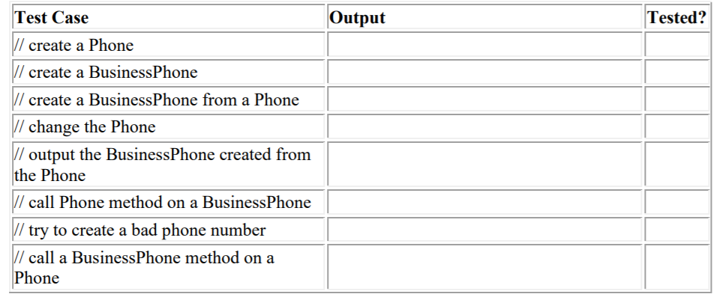

|  |  |
| --- | --- |
| Output | Tested |
| created | yes |
| Created | yes |
| Created | yes |
| Changed | yes |
| Printed | yes |
| Method called | yes |
| Tried but wasn’t possible since area code must be grater than 200 | yes |
| Tried but doesn’t work since phone is superclass and business phone is subclass | yes |